Practical - 13
Practical Title: PHP JSON API and AJAX/Fetch-Based CRUD without Page Reload

Create simple PHP JSON API endpoints for events or students and consume them using Fetch API. Perform list, add, update, and delete operations asynchronously without full page reload.

Theory
1. 1. Do PHP endpoints return valid JSON responses?
- Yes, PHP endpoints return valid JSON responses using json_encode().
- They set the Content-Type: application/json header.
- The responses can be tested to verify correct JSON formatting and data.
2. Are GET and POST requests handled properly?
- GET requests are handled properly to retrieve data and display results.
- POST requests are handled properly to submit data and perform create, update, or delete operations.
- Appropriate validation and error handling are implemented for both request methods.
3. Are loading, success, and error states shown on the frontend?
- Loading: Displays a loading indicator while data is being processed.
- Success: Shows a success message when the operation completes successfully.
- Error: Displays an error message if the operation fails.
4. Is input validation performed before database operations?
- Yes, input validation is performed before database operations to ensure the entered data is valid and complete.
- Invalid inputs are rejected with appropriate error messages, preventing incorrect data from being stored in the database.
Implementation/Output/Result

My learning codes: https://drive.google.com/file/d/1CPP3uUq3gdKZxC3pFB7iheZVU7FCImSx/view?usp=drive_link

Evidence of Work (Screenshots)
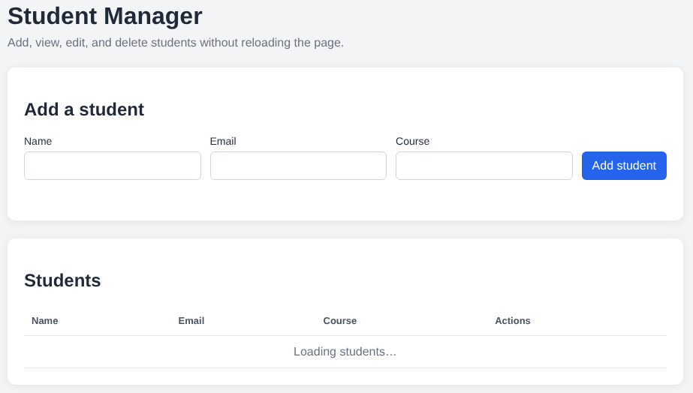
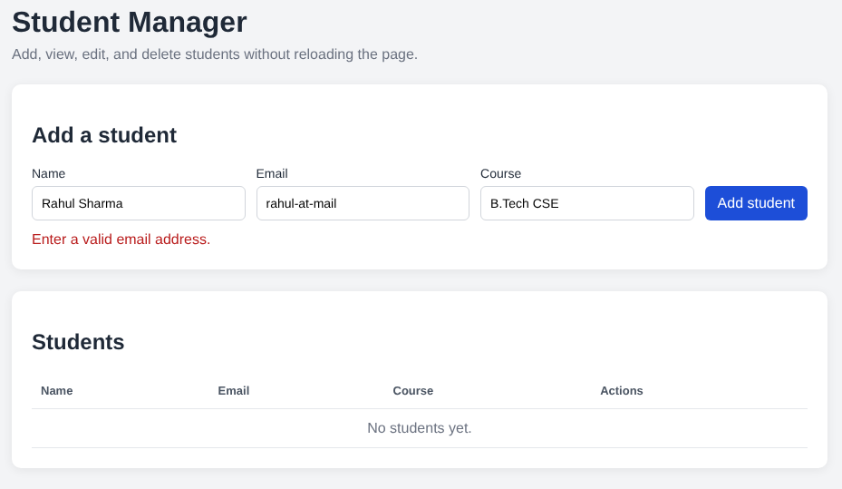
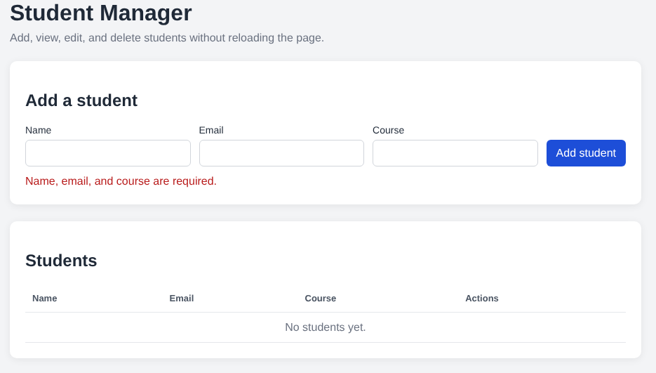
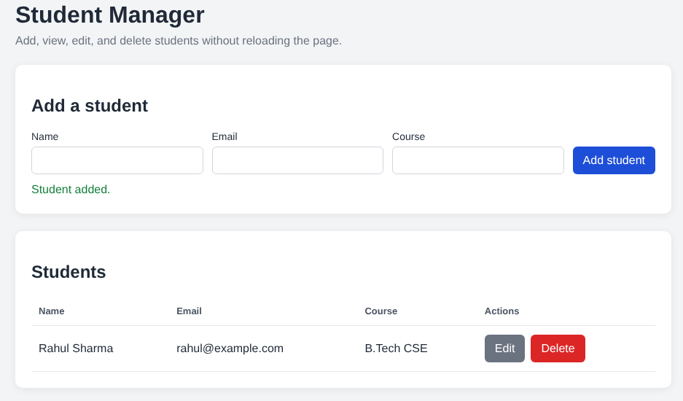

GitHub Repository Link:
Khushi-Thakor2007/Student-Hub-Portal

Challenges Faced:
- Generating clean and valid JSON responses from PHP endpoints.
- Handling PHP warnings and errors that could break JSON responses.
- Validating user inputs and displaying loading, success, and error messages.
- Synchronizing the UI with the database without reloading the page after CRUD operations.

Learning Outcomes:
- Learned to create JSON APIs in PHP using json_encode() and the Content-Type: application/json header.
- Learned to handle GET and POST requests properly.
- Learned to use the Fetch API for asynchronous CRUD operations.
- Learned to validate user inputs and provide clear feedback messages.

Faculty Remarks:

